Wheat
Wheat (Triticum aestivum L.) is the second most important cereal crop of India next to Rice. It is one of the major food grains of the country and a staple food of India. It is rich in proteins, vitamins and carbohydrates and provides balanced food. India is the fourth largest producer of wheat in the world after Russia,USA and China and accounts for 8.7 per cent of the world’s total production of wheat. It usually sown from the month of September to December in various states of India (Madhya Pradesh, Uttar Pradesh, Punjab, Haryana, Maharashtra, Bihar, Andhra Pradesh, Karnataka, Rajasthan, West Bengal).

1. Narrow and Broad Leaves

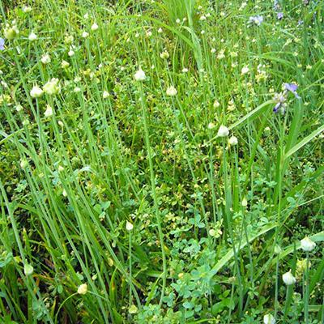

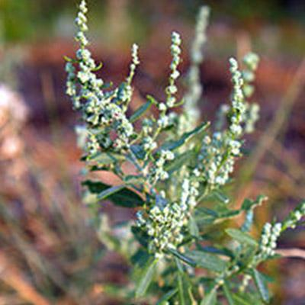

Weedmar Super

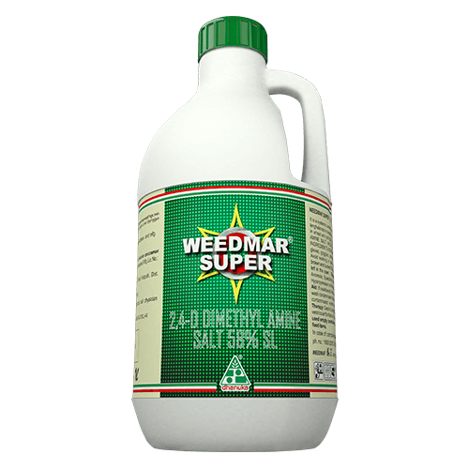
Weedmar Super (2,4-D Amine Salt 58% SL) and Weedmar are the selective, systemic weedicides of Phenoxyacetic group.
Weedmar Super is used on a wide variety of terrestrial and aquatic broadleaf weeds. It has little effect on grasses. It appears to work by causing uncontrolled cell division in vascular tissue. Abnormal increases in cell wall plasticity, biosynthesis of proteins, and production of ethylene occur in plant tissues following exposure, and these processes are responsible for uncontrolled cell division. The ester forms of 2, 4-D penetrate foliage, whereas plant roots absorb the salt forms. 2, 4-D appears to be similar in action to other auxin-type herbicides. .It is absorbed by the leaves and roots and translocated in to the weed plants.

PACK SIZE

250 ml, 500 ml, 1 ltr, 2.5 ltr, 5 ltr

FEATURES & BENEFITS
- Apart from effectively controlling broad leaf weeds, these also control the Cyperus sp.
- There is no adverse effect on crops with recommended dose of Weedmar or Weedmar Super.

2.Termites

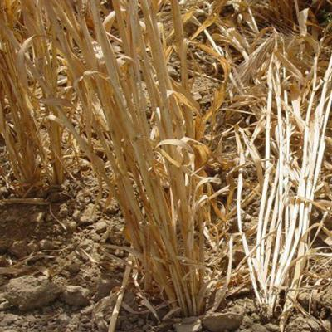

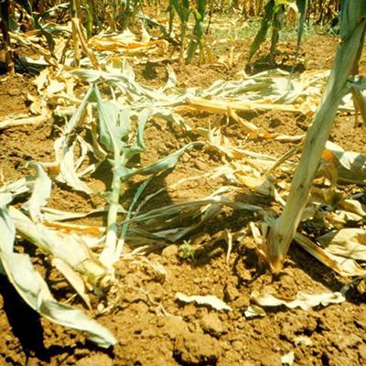

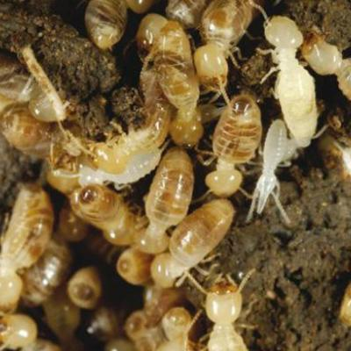

Areva Super

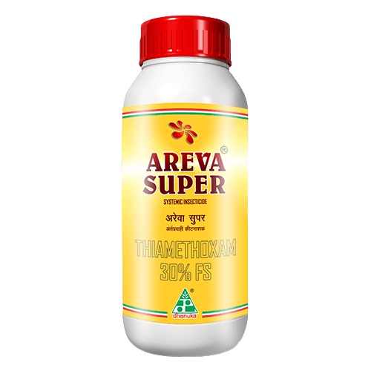
Areva Super (Thiamethoxam 30% Fs) is a systemic insecticide. Areva Super protects against target pests by interfering with receptors that transmit the message to continue feeding. Areva Super acts on different sites of action in the insect. Areva Super is to be used as a SEED DRESSER.
Areva super has contact, stomach, systemic activity. Areva Super is an agonist of the nicotinic acetylcholine receptor, affecting the synapses in the insect central nervous system.

PACK SIZE

500 ml, 1 Ltr

FEATURES & BENEFITS
- Areva super Protects against target pests by interfering with receptors that transmit the message to continue feeding.
- Areva super acts on different sites of action in the insect.

3.Caterpiller

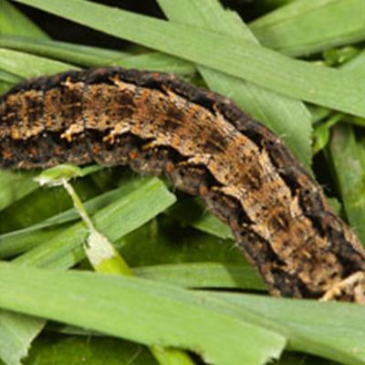

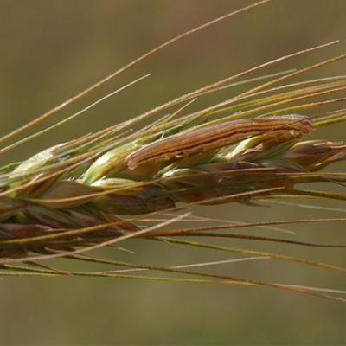

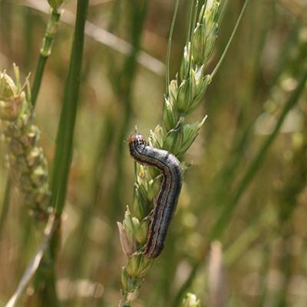

Dhanulux
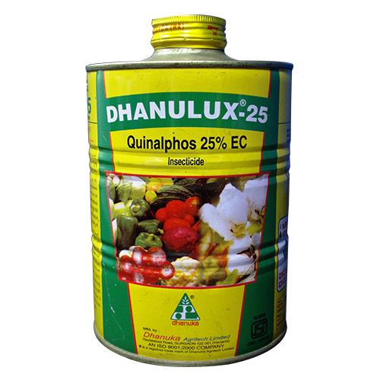
Dhanulux (Quinalphos 25% EC) a broad spectrum organo-phosphatic insecticide containing 25% w/w quinalphose a.l. in the form of emulsifiable concentrate. It is having broad spectrum of activity and good initial and residual toxicity against bollworms on cotton and stem borer, leaf folder, green leaf hopper, hispa on rice.
Dhanulux is a highly effective insecticide with contact and stomach action. Dhanulux can be applied as a foliar spray.

PACK SIZE

100 ml, 250 ml, 500 ml, 1 ltr, 5 ltr, 20 ltr

FEATURES & BENEFITS
- Effective against chewing and sucking insects and mites.
- Good residual action.
- Compatible with most pesticides,except those of alkaline nature.

4.Loose Smut
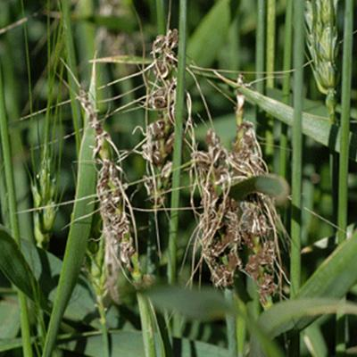

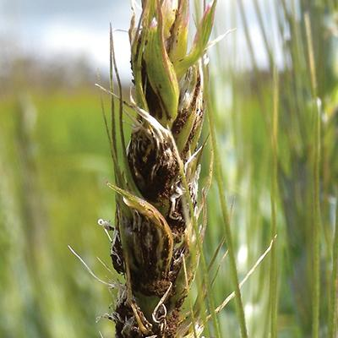

Dhanustin
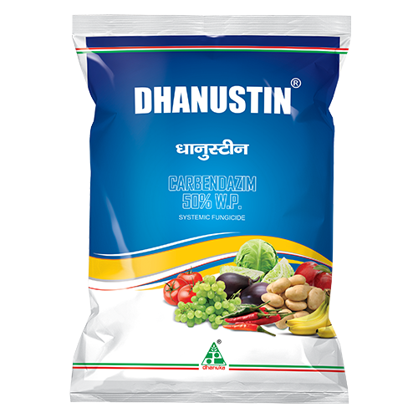
Dhanustin (Carbendazim 50% WP) is a broad spectrum systemic fungicide which effectively controls the diseases of crops. It is used both as curative and preventive for control of diseases in field crops and vegetables.
It is a broad-spectrum systemic fungicide with protective and curative action. It is taken and translocated within the plant as a result of which the latter become fungitoxic.

PACK SIZE

100 gm, 250 gm, 500 gm, 1 kg

FEATURES & BENEFITS
- Dhanustin formulation is one of the best in the industry. Broad spectrum fungicide, which controls large no. of diseases with its strong mode of action.
- As compare to other fungicides, it is less expensive in the long run with respect to the superior protection and cost per acre.

5.Karnal Bunt
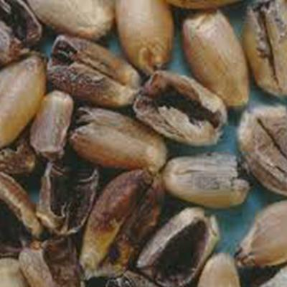
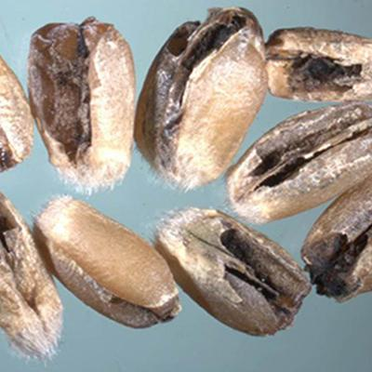

Zerox
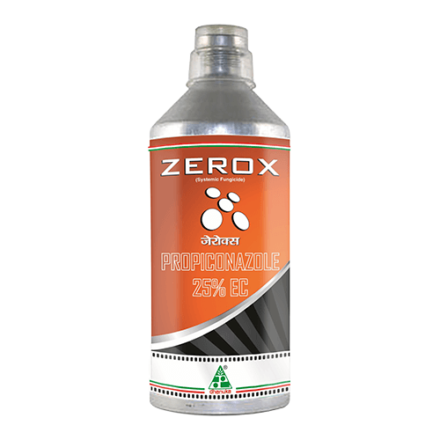
It is a systemic specialty fungicide. It is rapidly absorbed by the Leaves or stems and translocated upward through the xylem. It is a potent ergosterol biosynthesis inhibitor. Ergosterol, a principal sterol in most fungi is an indispensable component in the membrane structures. First spray at the initiation of infestation and subsequent spray after 7 to 10 days of the first spray or as and when required
Zerox (Propiconazole 25% EC) is a systemic fungicide of Triazole group with a broad range of activity. It's a broad-spectrum systemic foliar fungicide for the control of a wide range of leaf and stem diseases in cereals.

PACK SIZE

250 ml, 500 ml, 1 ltr

FEATURES & BENEFITS
- Zerox has both, curative and protective action, hence controls the plant diseases very effectively.
- Zerox has a long residual effect, hence gives control of diseases for a longer period.
- Zerox application in rice prevents the black dirty grains.

